https://password.port.ac.uk/sspr/public/activate

https://student-system.port.ac.uk/urd/sits.urd/run/siw_ipp_lgn.login

https://student-system.port.ac.uk/urd/sits.urd/run/siw_sso.saml

<https://student-system.port.ac.uk/urd/sits.urd/run/siw_sso.saml>

<https://student-system.port.ac.uk/urd/sits.urd/run/siw_sso.saml>

Open in new tab-

Open in new window-

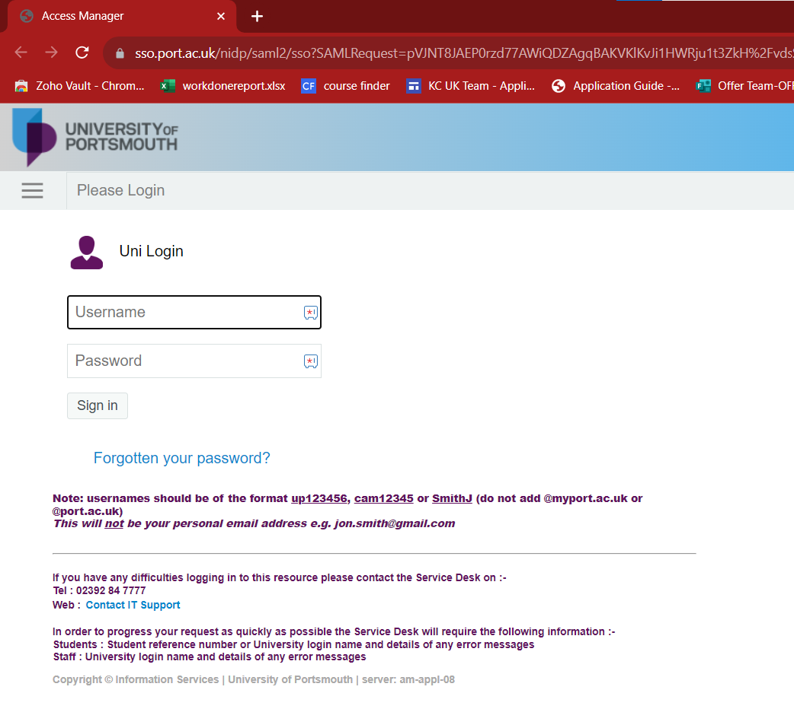

Open in incognito

Scroll bar-

To check forgotten password

Working of contact support link

